
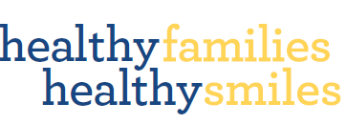
Think about how you can do this across all areas:
- Learning experiences
- Engaging families
- Professional practice and organisational policies

Action Plan
What could you incorporate into your service / your practice to improve the oral health of children?
Issue  What’s happening in our service?  → What do we want to happen? | Strategy  How could we resolve this?  What needs to be done? What can our service do? | Examples  See Healthy Little Smiles resource kit — page ___ | Link to NQS or EYLF

