Communication toolkit for schools
Toolkit information sheet

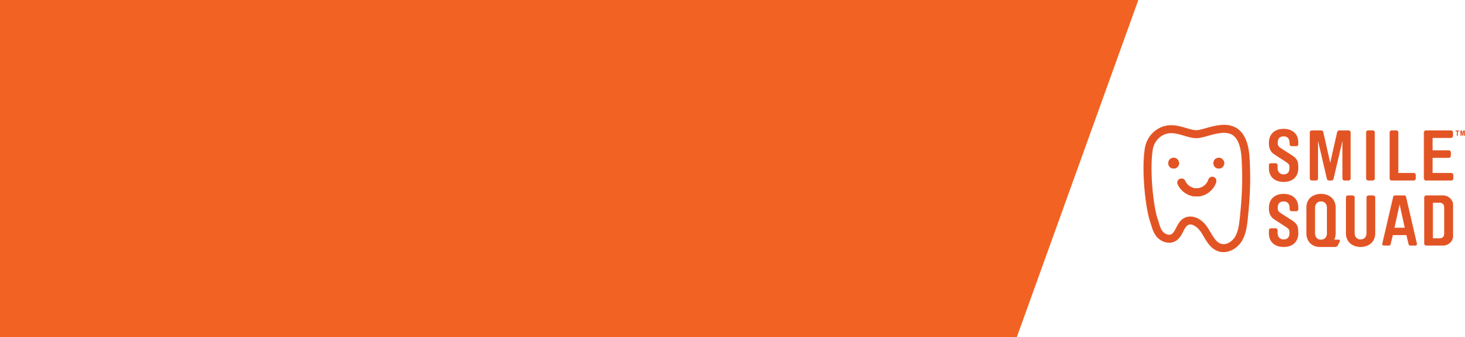

What’s in the toolkit?
This toolkit includes the following resources that can be used to promote the Smile Squad free school dental program to school communities:
- Newsletter and website content (including a Smile Squad badge for your website)
- Social media and school portal content
- Image tiles
- Smile Squad posters
- Smile Squad brochures

Printed resources
Schools receive printed copies of the following resources before Smile Squad visit:
- Smile Squad posters
- Eat well, drink well, clean well oral health brochure (via the dental packs)
Copies of the Smile Squad parent brochure and additional posters can be ordered at no cost by emailing smilesquad@dhsv.org.au

Translated resources
The following resources are available to download from the Smile Squad How to keep teeth health page: https://www.smilesquad.vic.gov.au/how-keep-teeth-healthy
- Eat well, drink well, clean well brochure
- Smile Squad parent brochure

Tips for promoting the Smile Squad message
We have created a series of messages you can copy and paste, adapt and share via school communication channels.
We have also provided some suggestions about the right time to share each type of content.
- Be prepared – share information in advance of a Smile Squad visit so that families are prepared and informed.
- Localise your message – Use your knowledge of your school community to make your messages more meaningful to your audience.
- Consider your channels – Every school is different so think about how best to reach families. Place an article in your school newsletter and consider social media if you use it. Don’t worry about repeating these messages. The average number of times a person needs to hear a message in order to recall it is 3-5 times. So keep saying it.

Contact
Thank you for supporting Smile Squad and sharing the messages in this toolkit. Please let us know if there is anything you would like to see in this toolkit in the future.
Email: smilesquad@dhsv.org.au

